Macintosh HD:Users:gwilliams:Documents:My Work:My Work:ALL FILES:Active:Maths General:PLC Crest:PLC Crest and Byline.eps

**MATHEMATICS DEPARTMENT**

**Year 12 MATHEMATICS SPECIALIST**

**TEST 4: DIFFERENTIATION AND DIFFERENTIAL EQUATIONS**

DATE: 28th June 2016 Name__________________________

**Reading Time:** 3 minutes

**SECTION ONE: CALCULATOR FREE**

TOTAL: 33 marks

EQUIPMENT: Pens, pencils, pencil sharpener, highlighter, eraser, ruler, SCSA formula sheet.

WORKING TIME: 30 minutes (maximum)

**SECTION TWO: CALCULATOR ASSUMED**

TOTAL: 25 marks

EQUIPMENT: Pens, pencils, pencil sharpener, highlighter, eraser, ruler, drawing instruments, templates, up to 3 Calculators,

1 A4 page of notes (one side only), SCSA formula sheet.

WORKING TIME: 20 minutes (minimum)

|  |  |  |  |  |  |
| --- | --- | --- | --- | --- | --- |
| **SECTION 1**  **Question** | **Marks available** | **Marks awarded** | **SECTION 2**  **Question** | **Marks available** | **Marks awarded** |
| **1** | **6** |  | **5** | **8** |  |
| **2** | **6** |  | **6** | **8** |  |
| **3** | **11** |  | **7** | **9** |  |
| **4** | **10** |  |  |  |  |
|  |  |  |  |  |  |
|  |  |  |  |  |  |
| **Total** | **33** |  |  | **25** |  |

Section One: Calculator-free [33 marks]

This section has four (4) questions. Answer all questions. Write your answers in the spaces provided.

Question 1 [6 marks]

A first order differential equation is given by 

(a) Use the equation to complete the table below. [2]

|  |  |  |  |  |  |  |
| --- | --- | --- | --- | --- | --- | --- |
|  | -2 | -1 | 0 | 1 | 2 | 3 |
|  | 2 | 2 | 2 | 2 | 2 | 3 |
|  |  |  |  |  |  |  |

(b) Create a slope field on the 10 points on the graph below. [2]

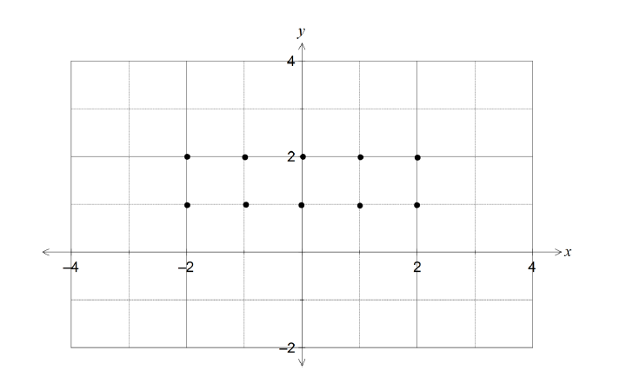

(c) Find the solution that passes through the point given by  and . [2]

Question 2 [6 marks]

A function is defined parametrically by the equations  and 

(a) Find  in terms of  [2]

(b) By finding the second derivative,  in terms of , show that there are no points of inflection on this curve. [4]

**Question 3 [11 marks]**

The equation of a curve in the plane is 

(a) Show that for all points on the curve  [4]

(b) Find the equation of the tangent to the curve at the point . [3]

(c) At what points on the curve is the tangent parallel to the *y*-axis? [4]

Question 4 [10 marks]

The volume *V* of blood flowing through an artery in unit time can be modelled by the formula  where *r* is the radius of the artery and *k* is a constant.

(a) What is the effect on the volume of blood flow if the radius of the artery is halved?

[2]

(b) Use the incremental formula to estimate the percentage decrease in the radius of a

partially clogged artery that will produce a 10% decrease in the flow of blood. [5]

(c) Show that the incremental formula gives a physically absurd estimate for the change

in *V* resulting from a halving of the radius of the artery. Explain why this

estimate is so poor compared to the true answer found in (a). [3]

**YEAR 12 MATHS SPECIALIST TEST 4 2016**

**NAME:________________________________________________**

**Section Two: Calculator-assumed [25 marks]**

This section has three (3) questions. Answer all questions. Write your answers in the spaces provided

Question 5 [8 marks]

The needle in a sewing machine moves vertically with simple harmonic motion, and the distance between the highest and lowest positions of the tip is 8 mm.

The height of the tip of the needle above its mid-point position *t* seconds after it starts to move is *x(t)* mm, where *x(t)* satisfies the differential equation



(a) Determine *x*(*t*), given that the needle starts at its highest point. [3]

(b) How long does it take for the needle to return to its highest point? [2]

(c) How far does the tip travel in the first 0.3 seconds? [3]

Question 6 [8 marks]

A searchlight S is just above sea level and is revolving in the horizontal plane. The searchlight is located 15 metres out to sea from the nearest point N on a straight beach. S and N are in the same horizontal plane and the searchlight rotates at 2 revolutions per minute.

N

A

S (Searchlight)

15 m

Beach

Determine the rate at which the beam of light is moving along the beach when:

(a) the beam illuminates the beach at a point A such that the angle SAN is 30° [6]

(b) the beam illuminates at a point B on the beach 39 metres from S. [2]

Question 7 [9 marks]

The expected uptake of a new model of smart phone in a country, currently with one million models in use, can be modelled by the logistic equation , where  is the total number of models in millions and is the time in weeks.

(a) Express  as a function of  in the form  where  and  are positive

constants. [5]

(b) Calculate

(i) the expected number of models in use after 30 weeks. [1]

(ii) the week during which the number of models in use is increasing at the greatest rate. [3]

END OF QUESTIONS